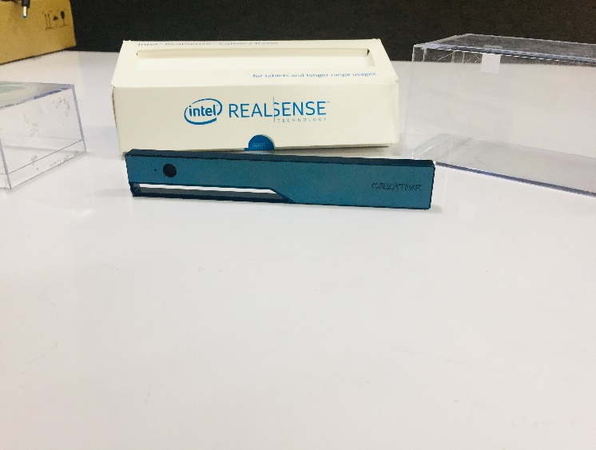Intel® RealSense™ Camera R200 3D CAD Files

**Requerimientos mínimos del sistema**

• 1 GB de espacio de almacenamiento en disco (1)

• Memoria de 2GB (1)

• USB3

• Cable de interconexión R200 (2)

(1) Es posible que se requiera espacio de disco y memoria adicionales para

ciertas aplicaciones Consulte la aplicación mínima.

(2) Proporcionado por el integrador del sistema. Diseño de cable es

Específico para la definición del sistema y cumple con el diseño del cable R200.

presupuesto.

(3) Póngase en contacto con el representante local de Intel para obtener el último sistema operativo y

|  |  |
| --- | --- |
| **Parameter** | **R200 Color Camera** |
| Active Pixels | 1920x1080 |
| Sensor Aspect Ratio | 16:9 |
| Filter Type | IR Cut Filter |
| Focus | Fixed |
| Shutter Type | Rolling Shutter |
| Vertical Field of View | 43o +/-2o |
| Horizontal Field of View | 70o +/-2o |
| Diagonal Field of View | 77o +/-4 |

Soporte de plataforma.

|  |  |
| --- | --- |
| **Acronym** | **Definition** |
| AR | Anti-Reflective (Coating) |
| ASIC | Application Specific Integrated Circuit |
| Baseline | Distance between Left and Right Infrared Imager |
| CMC | Common Mode Choke |
| EMI | Electromagnetic Interference |
| ESD | Electrostatic Discharge |
| FEA | Finite Element Analysis, a type of mechanical simulation |
| FHD | Full High Definition |
| FOP | Field of Projection (Horizontal/Vertical/Diagonal) |
| FOV | Field of View (Horizontal/Vertical/Diagonal) |
| GPIO | General Purpose Input/Output |
| IR | Infrared |
| LED | Light Emitting Diode |
| PCB | Printed Circuit Board |
| R200 | Intel® RealSense™ R200 |
| RFI | Radio Frequency Interference |
| TBD | To Be Determined |
| TDP | Thermal Design Power |
| TIM | Thermal Interface Material |
| TJ | Component Junction Temperature |
| USB | Universal Serial Bus |

|  |  |
| --- | --- |
| **Parameter** | **Laser Projector** |
| Projector | Static Infrared Pattern |
| Illuminating Component | Infrared Laser Diode |
| Laser Wavelength | 859nm Nominal |
| R200 Laser Compliance | Class 1, IEC 60825-1:2007 Edition 2 |
| Vertical Field of Projection | 60o +/-5o |
| Horizontal Field of Projection | 60o +/-5o |
| Diagonal Field of Projection | 80o +/-5 |

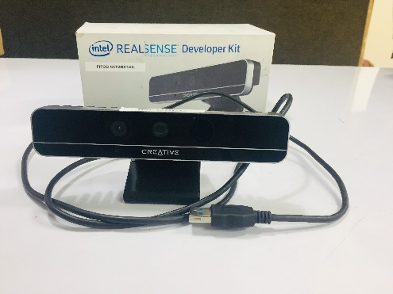**F200**

Conexion USB

Solo soportada en windows

Diseñada para ver el usuario y reconocer gestos de voz, manos y rostro

**Especificaciones de operación**

|  |  |
| --- | --- |
| Resolución y FPS profundos | VGA 30fps |
| Campo de vision profundo | H: 73, V: 59, D: 90 |

## Especificaciones de modulo

|  |  |
| --- | --- |
| Dimensiones | 110mm x 12.5mm x 3.75mm |
| Tipo de interfaz de sistema | USB3 |

## Components

|  |  |
| --- | --- |
| Sensor de RGB | SI |

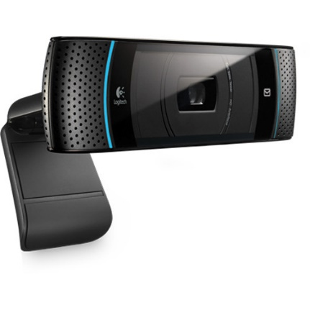**Logitech HD 720p TV Cam for Skype**

**Es compatible con Windows.**

**Product Highlights**

* High-Grade HD 720p
* Video Call From Your TV
* Premium Autofocus
* Wide-Angle Lens

|  |  |
| --- | --- |
|  | |
|  | |
|  |  |
| **Product Identifiers** | |
| Brand | Logitech |
| MPN | 960-000665 |
| UPC | 0097855071491 |
| Model | TV Cam |
| **Product Key Features** | |
| Connectivity | USB 2.0 |
|  |  |
| **Additional Product Features** | |
| Max. Video Resolution | 1280x720 |
| Built-In Microphone | Built Indiana Microphone |

Resolución máx.: 720p/30 fps

Tipo de enfoque: foco fijo

Tecnología de lente: estándar

Micrófono integrado: mono

Campo visual: 60°

* Clip universal para monitores, pantallas LCD o laptops